**Name : Aarya Tiwari**

**Batch : A3**

**Roll No. : 16010421119**

**Course: Cloud Computing**

**Experiment No. : 3**

**Creating EC2 Instance**

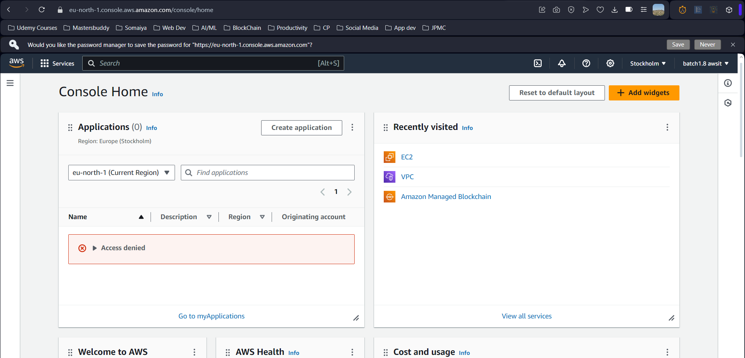

**Adding Name and Machine Image**

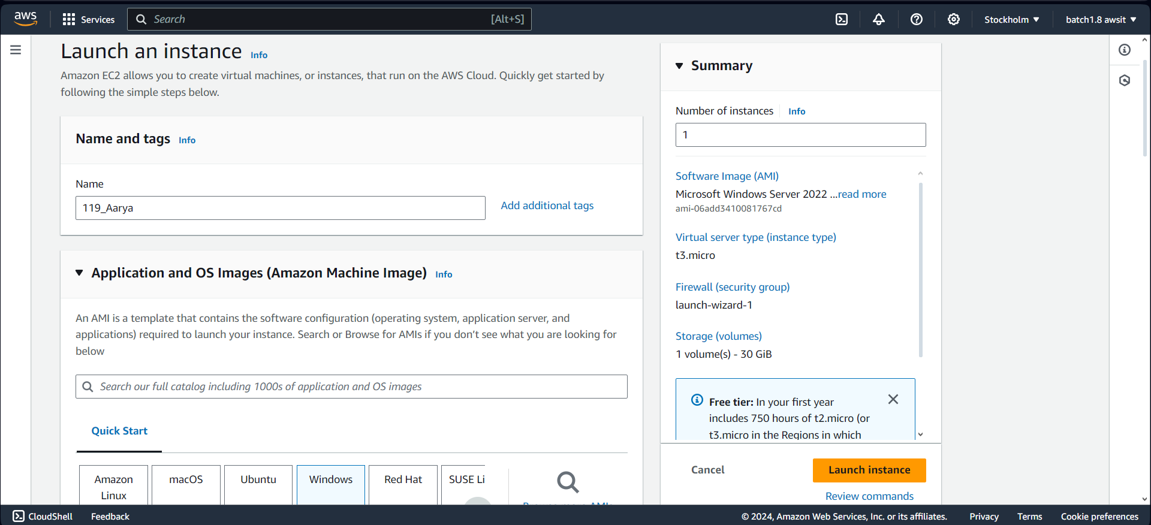

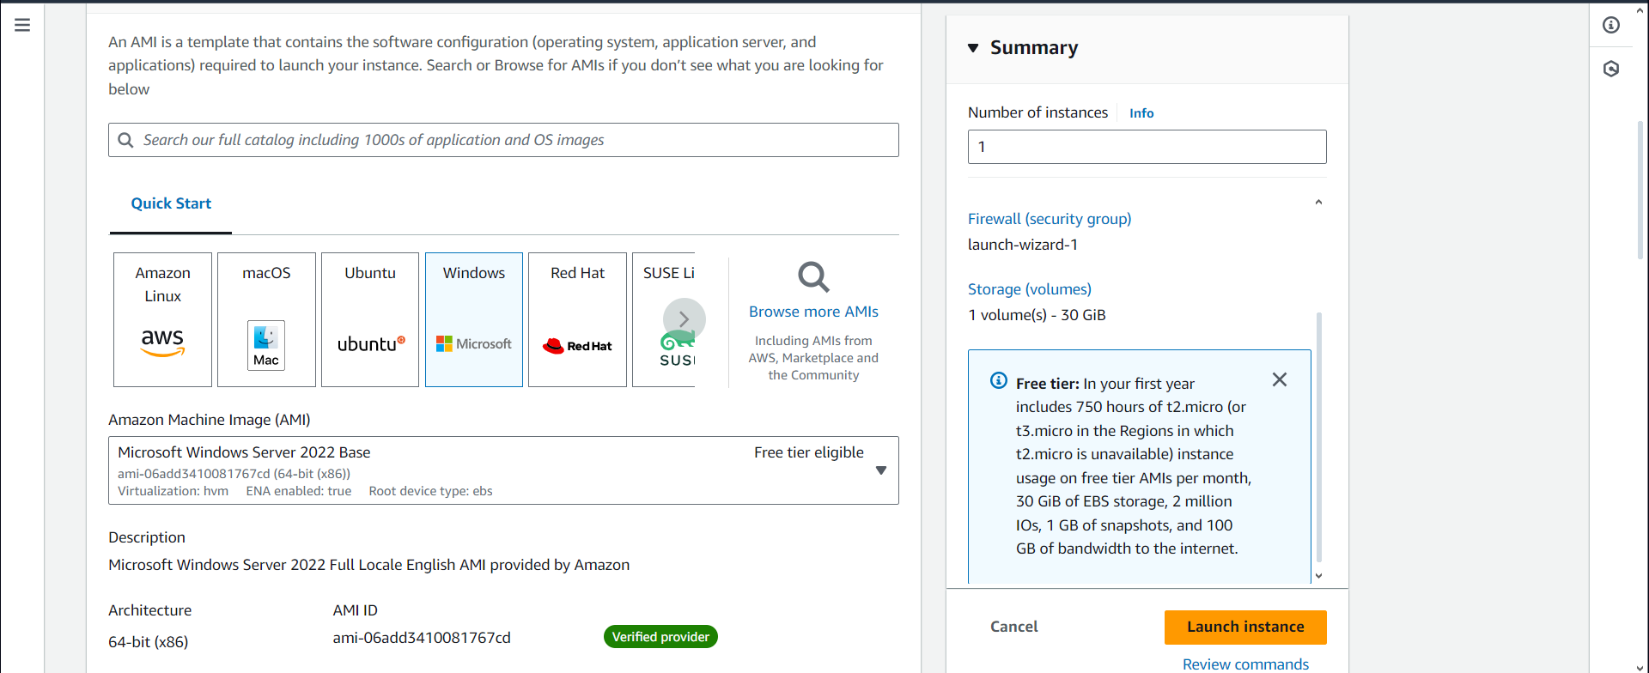

**Adding Key Value Pair**

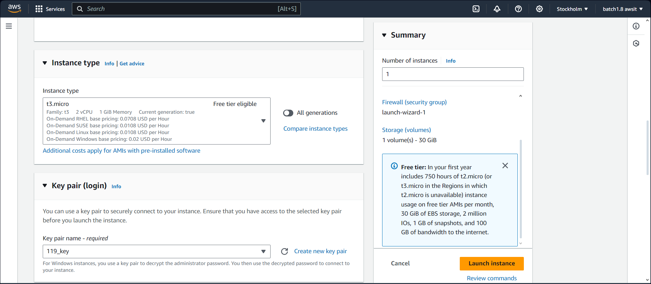

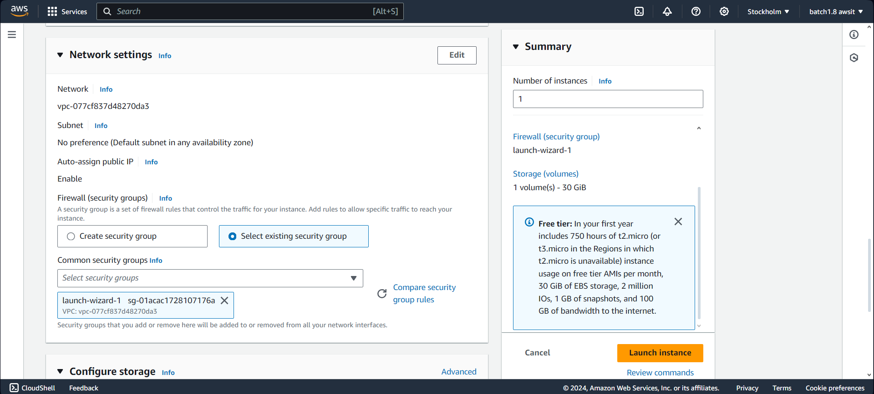

**Adding Existing Security Group**

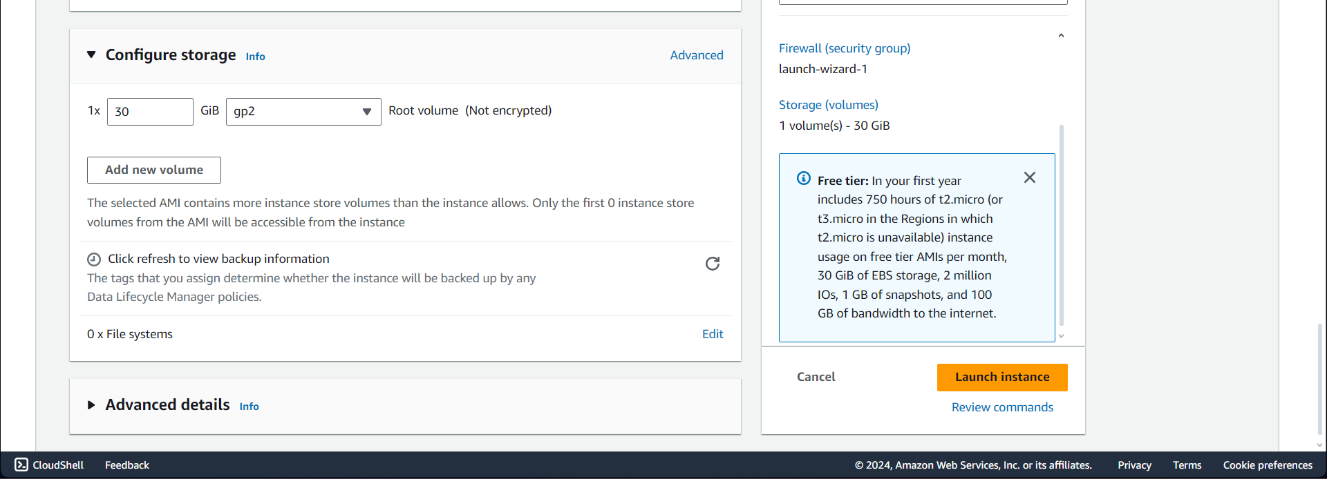

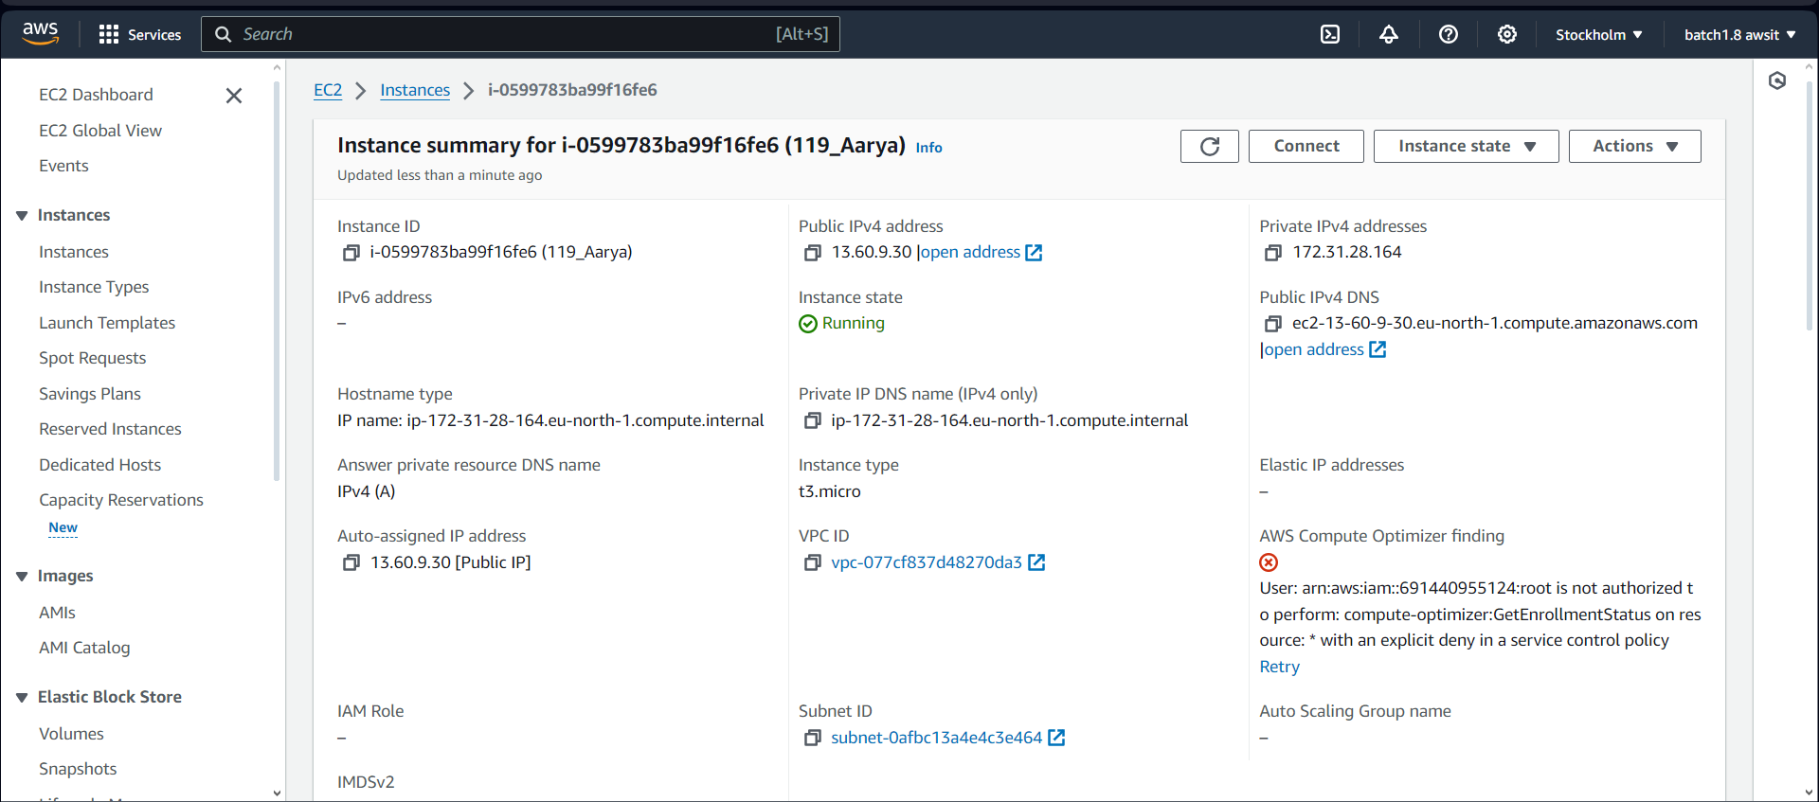

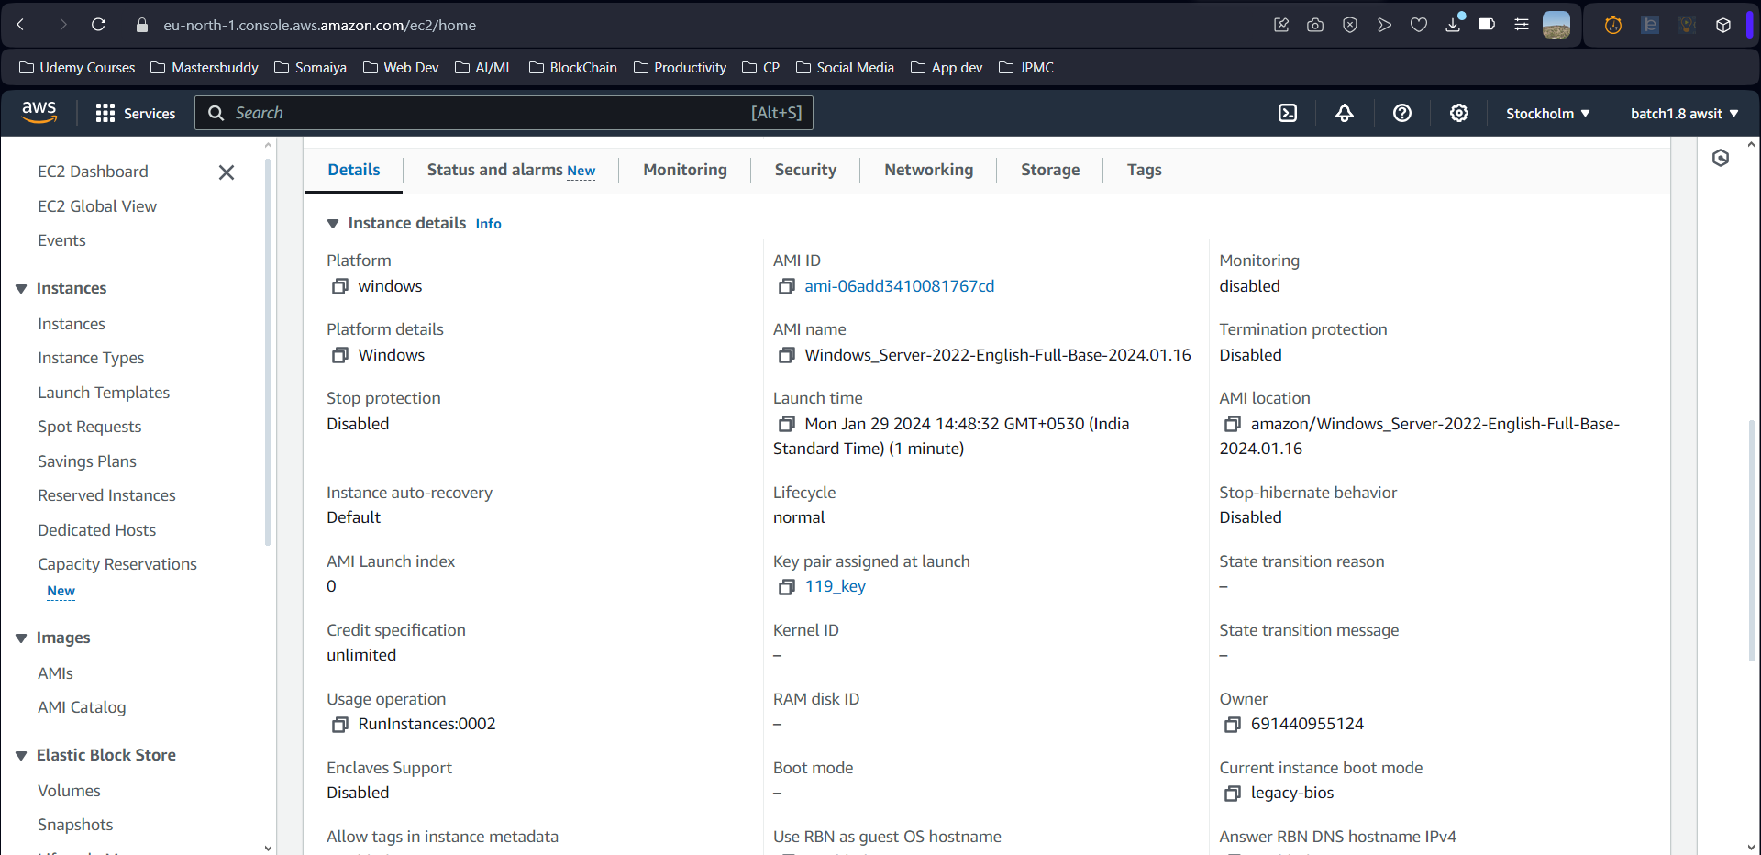

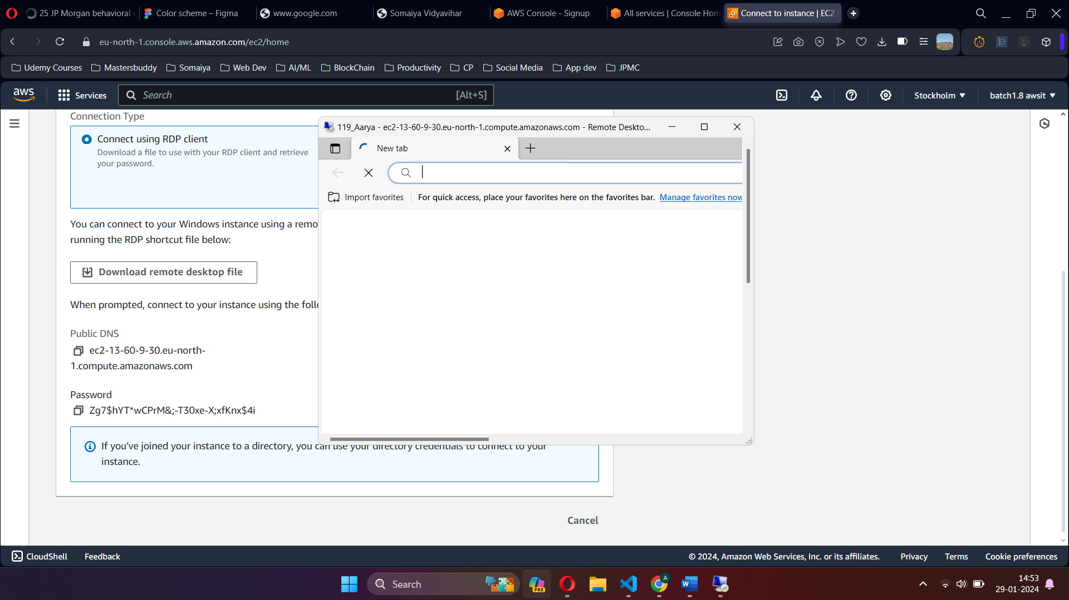

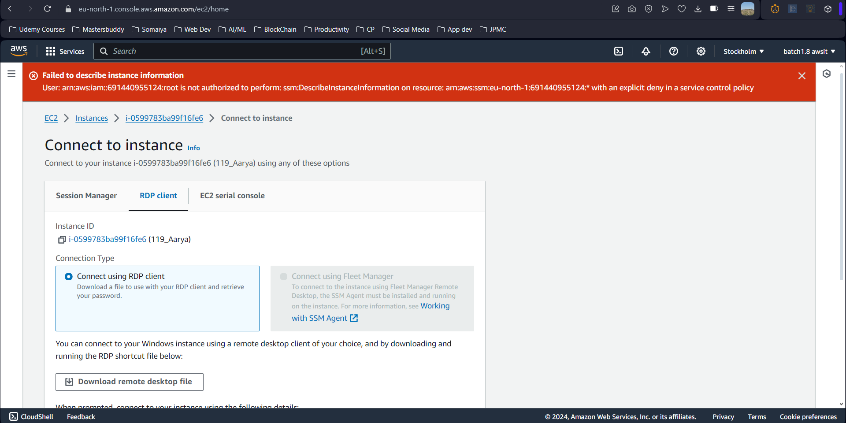

**Connecting Instance using RDP Client**

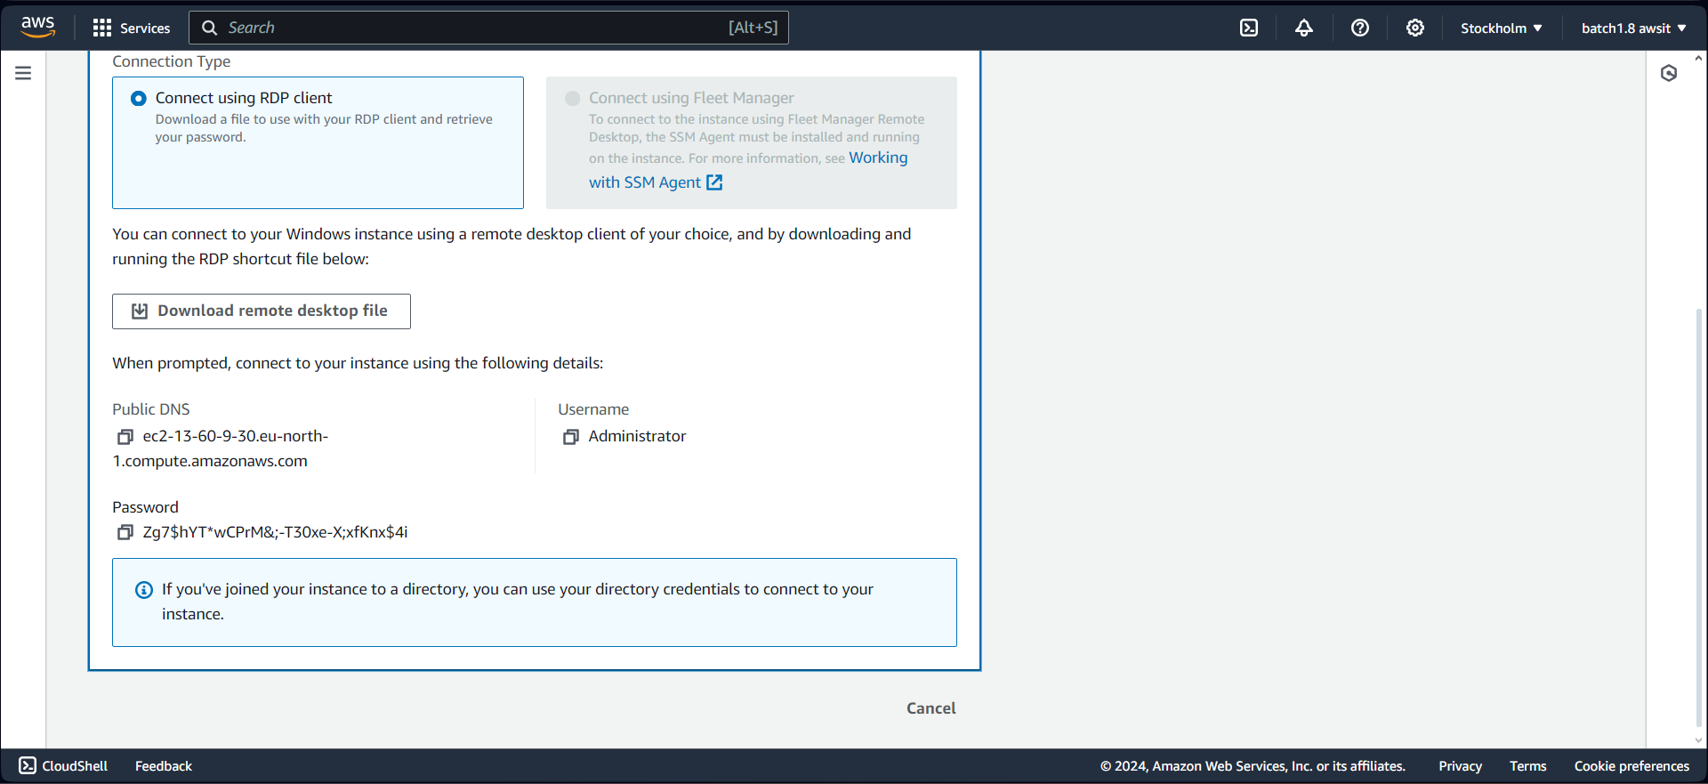

**Instance Created**

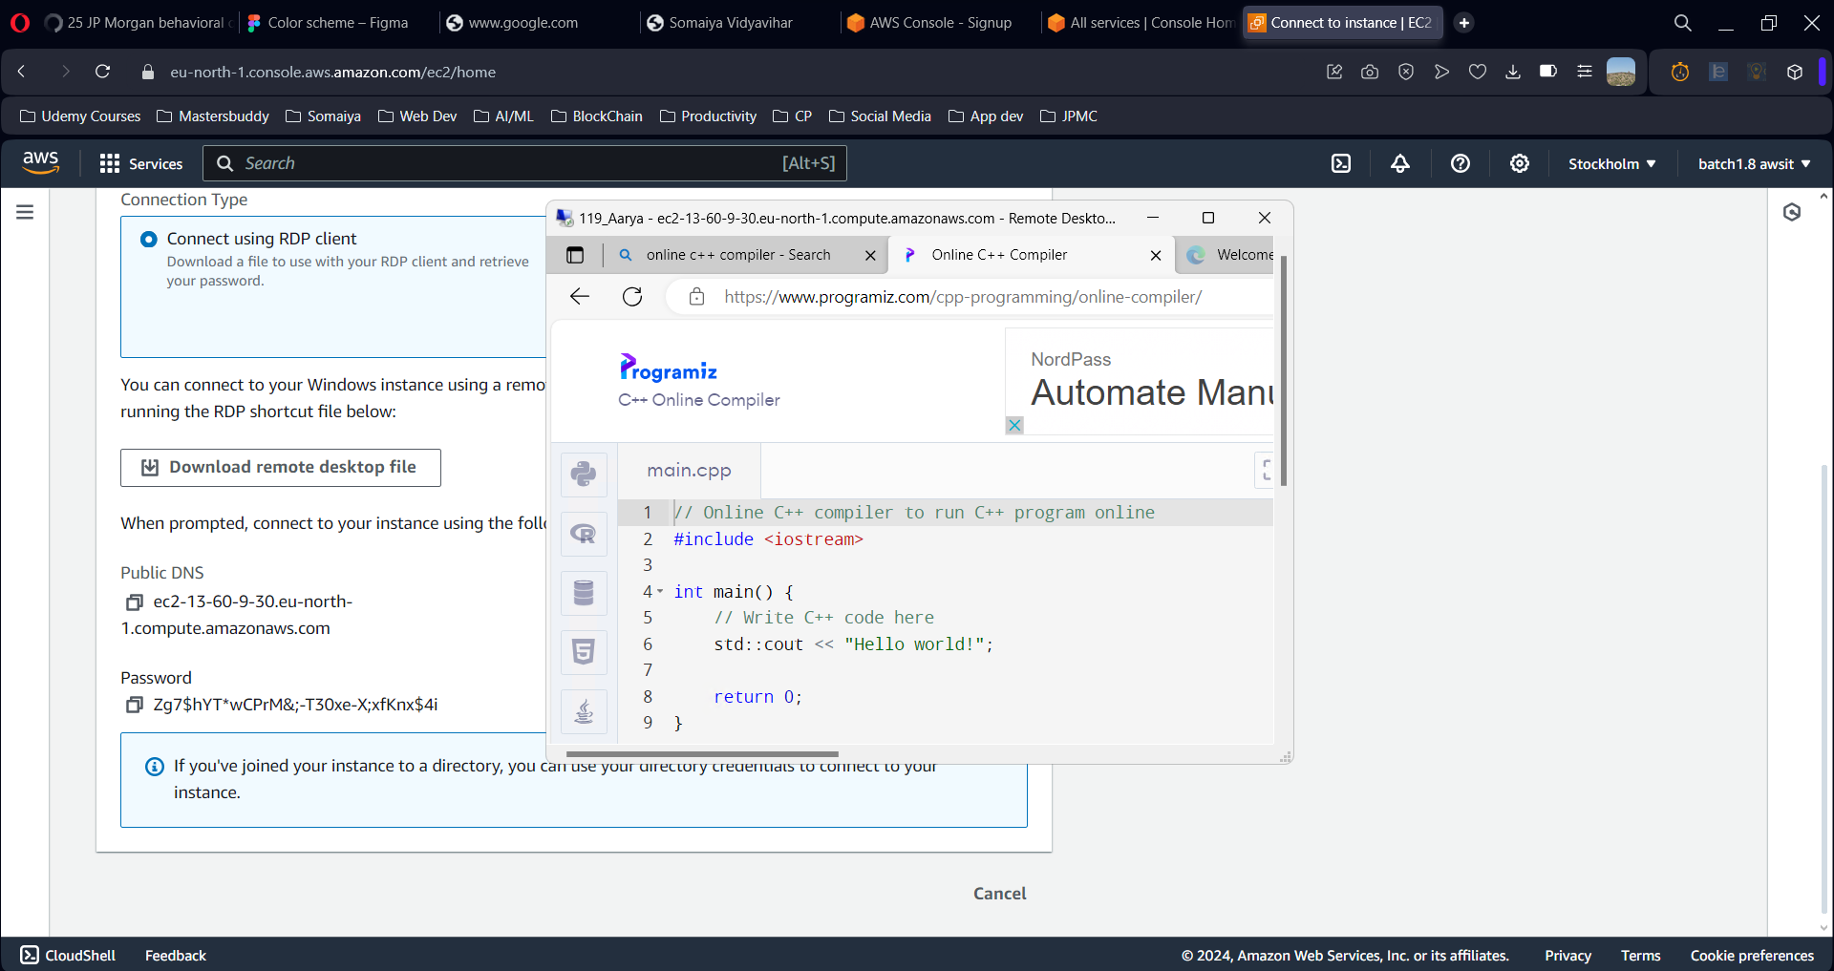

**Running Hello World in Instance**

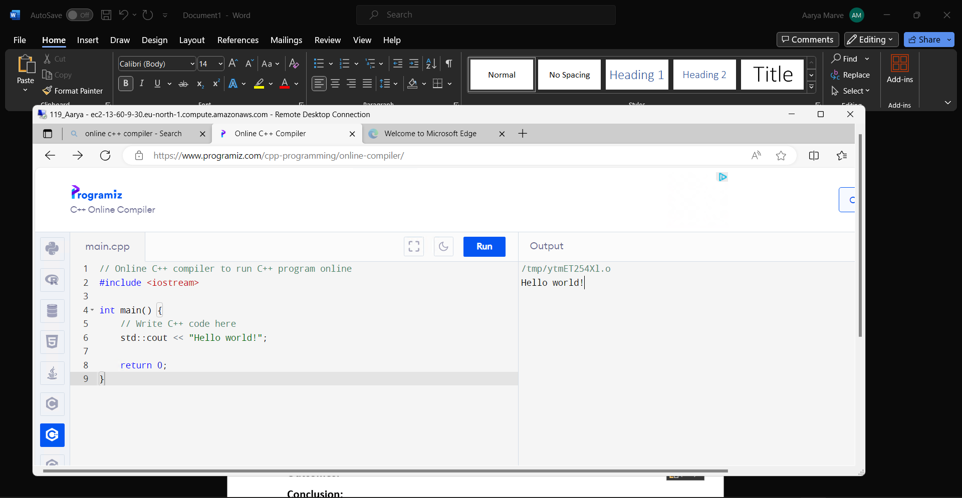

**Post Lab Questions:**

**Q1 . Explain two AWS IaaS, PaaS and SaaS services for each?**

**Ans.**

**IaaS (Infrastructure as a Service):**

* **Amazon EC2 (Elastic Compute Cloud):** This service provides virtual servers in the cloud, allowing you to rent computing capacity with a wide range of configurations. You have full control over the servers and can install any operating system or software needed for your applications.
* **Amazon S3 (Simple Storage Service):** S3 offers object storage for data of any size and type. It's highly scalable, durable, and cost-effective, making it suitable for various use cases like backups, archiving, and hosting static website content.

**PaaS (Platform as a Service):**

* **AWS Elastic Beanstalk:** This service simplifies deployment and scaling of web applications. It supports various programming languages and frameworks, allowing you to focus on application development while Elastic Beanstalk manages the underlying infrastructure.
* **AWS Lambda:** Lambda provides a serverless compute service. You can upload code that executes in response to events without managing servers. This is ideal for running short-lived tasks or microservices triggered by user actions or data changes.

**SaaS (Software as a Service):**

* **Amazon WorkMail:** This service offers a secure, managed email and calendaring solution. It integrates with your existing directory services, allowing users to access their email and calendar through a web browser or mobile app.
* **Amazon Chime:** Chime provides a cloud-based communication platform for voice, video, and chat. It facilitates collaboration within teams and with external guests, eliminating the need for separate video conferencing or chat applications.

**Outcomes:**

CO2:Study the Evolution of Cloud Computing and its models

**Conclusion:**

We can conclude that we have learnt that Creating Window Virtual Machine Instance using AWS (IaaS)